# A. Title: Study of BJT Biasing Circuit

# B. Abstract:

The operating point (Q) of BJT is very important for amplifiers, since a wrong ‘Q’ point selection increases amplifier distortion. It is imperative to have a stable ‘Q’ point, meaning that the operating point should not be sensitive to variation to temperature or BJT ***β***, which can vary widely. In this experiment, four different circuits will be analyzed for two different ***β*** to check the stability of biasing points.

The analysis of the BJT circuits is a systematic process. Initially, the operating point of a transistor circuit is determined then the small signal BJT model parameters are calculated. Finally, the dc sources are eliminated, the BJT is replaced with an equivalent circuit model and the resulting circuit is analyzed to determine the voltage amplification (AV), current amplification (Ai), Input impedance (Zi), Output Impedance (Zo), and the phase relation between the input voltage (Vi) and the output voltage (Vo).

The experiment is a very good practical realization of bipolar junction transistor (BJT) biasing circuit.A BJT biasing circuit will be designed and simulated to find a DC operating point using a circuit simulation tool. Then a fixedbiasing and a self-biasing BJT circuits will be implemented on the trainer board to find a DC operating point for two different β of the transistor.

# C. Introduction:

The main objectives of this experiment are to-

1. Establish the proper operating point

2. Study the stability of the operating point with respect to changing ***β*** in different biasing circuits

# D. Theory and Methodology:

The dc analysis is done to determine the mode of operation of the BJT and to determine the voltages at all nodes and currents in all branches. The operating point of a transistor circuit can be determined by mathematical or graphical (using transistor characteristic curves) means. Here we will describe only the mathematical solution.

 

Fig 1:Biasing Circuit

We will use the most commonly applied biasing circuit to operate the BJT as an amplifier. A single power supply is used and the voltage divider network consisting of RB1 and RB2 is used to adjust the base voltage. Using the Theveninequivalent, the voltage divider network is replaced by Vth and Rth where,

and

The dc analysis of the circuit is simple by applying two KVL's at the input and theoutput loop.

If the BJT is in the active mode the following typical values can be observed:

and

RC is used to adjust the collector voltage. Finally, RE is used to stabilize the dcbiasing point (operating point). Using the above equations, the stability of biasing points for different transistor of β can be calculated.

**Note:** It is a good idea to set the bias for a single stage amplifier to half the supply voltage, as this allows maximum output voltage swing in both directions of an output waveform. For maximum symmetrical swing, it is clear from the figuresthat VCE should be VCE= VCC/2.

**E. Apparatus:**

|  |  |  |  |  |
| --- | --- | --- | --- | --- |
| 1) | Trainer Board | : |  | [ 1pc ] |
| 2) | Transistor | : | C828(NPN)  BD135(NPN) | [ 1pc ]  [ 1pc ] |
| 3) | Resistors | : | R=22KΩ | [ 1pc ] |
|  |  |  | RC= 470Ω  RB1 = 10KΩ  RE = 560Ω  RB=500K(Potentiometer) | [ 1pc ]  [ 1pc]  [1pc] |
| 4) | DC Power Supply (VCC = +15V DC) |  |
| 5)  6) | Multimeter  Power Supply Cable | : |  | [ 1pc] |

# F. Precautions:

# Transistors are sensitive to be damaged by electrical overloads, heat, humidity, and radiation. Damage of this nature often occurs by applying the incorrect polarity voltage to the collector circuit or excessive voltage to the input circuit. One of themost frequent causes of damage to a transistor is the electrostatic discharge from the human body when the device is handled. The applied voltage, current should not exceed the maximum rating of the given transistor.

**G. Experimental Procedure:**

# 1. The value of RC was measured by using multimeter and record. 2. The value of β was measured by using a multimeter for each transistor. 3. The fixed bias circuit with transistors was constructed. 4. 500k potentiometer was adjusted until VCE was approximately equal to VCC/2. 5. VCE , VBE and VRC was measured and after that calculated IC from VRC and RC. Also IB was calculated from IC. 6. Then replaced the first transistor by second one (Different β) and repeated the step 5. 7. The fixed bias circuit was constructed and repeated step 4, 5, 6. 8. The self bias circuit was constructed and repeated step 4, 5, 6. 9. Again constructed the self bias circuit and repeated step 4, 5, 6

**H. Circuit Diagrams:**



**Fixed bias circuits**

**Self bias circuits**



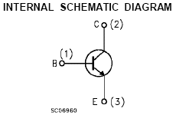

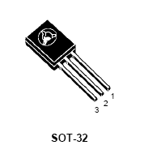

**I. Data Table:**

|  |  |  |  |  |  |  |
| --- | --- | --- | --- | --- | --- | --- |
|  | **β** | **VCE**  **(V)** | **VBE**  **(V)** | **VRC**  **(V)** | **IC**  **(mA)** | **IB**  **(mA)** |
| **Fig. 1 (a)** | 92 | 7.5 | 0.74 | 7.60 | 1.12 | 1.07 |
| 210 | 7.47 | 0.635 | 7.44 | 1.13 | 1.05 |
| **% of Change.** | 56.19% | 0.40% | 16.54% | 2.15 | 0.88% | 1.90% |
| **Fig. 1 (b)** | 92 | 7.49 | 0.739 | 3.442 | 1.13 | 1.11 |
| 210 | 7.55 | 0.633 | 3.445 | 1.12 | 1.09 |
| **% of Change.** | 56.19% | 0.79% | 16.75% | 0.09% | 0.88% | 1.83% |
| **Fig. 2 (a)** | 92 | 7.73 | 0.740 | 3.312 | 1.11 | 0.35 |
| 210 | 7.43 | 0.63 | 3.464 | 1.11 | 0.25 |
| **% of Change.** | 56.19% | 4.04% | 17.46% | 4.39% | 0% | 40% |
| **Fig. 2 (b)** | 92 | 7.47 | 0.687 | 7.63 | 16.55 | 0.08 |
| 210 | 7.47 | 0.648 | 7.77 | 16.85 | 0.072 |
| **% of Change.** | 56.19% | 0% | 6.02% | 1.8% | 1.78% | 11.11% |

# J. Simulation:

**Fixed bias(beta = 92)**

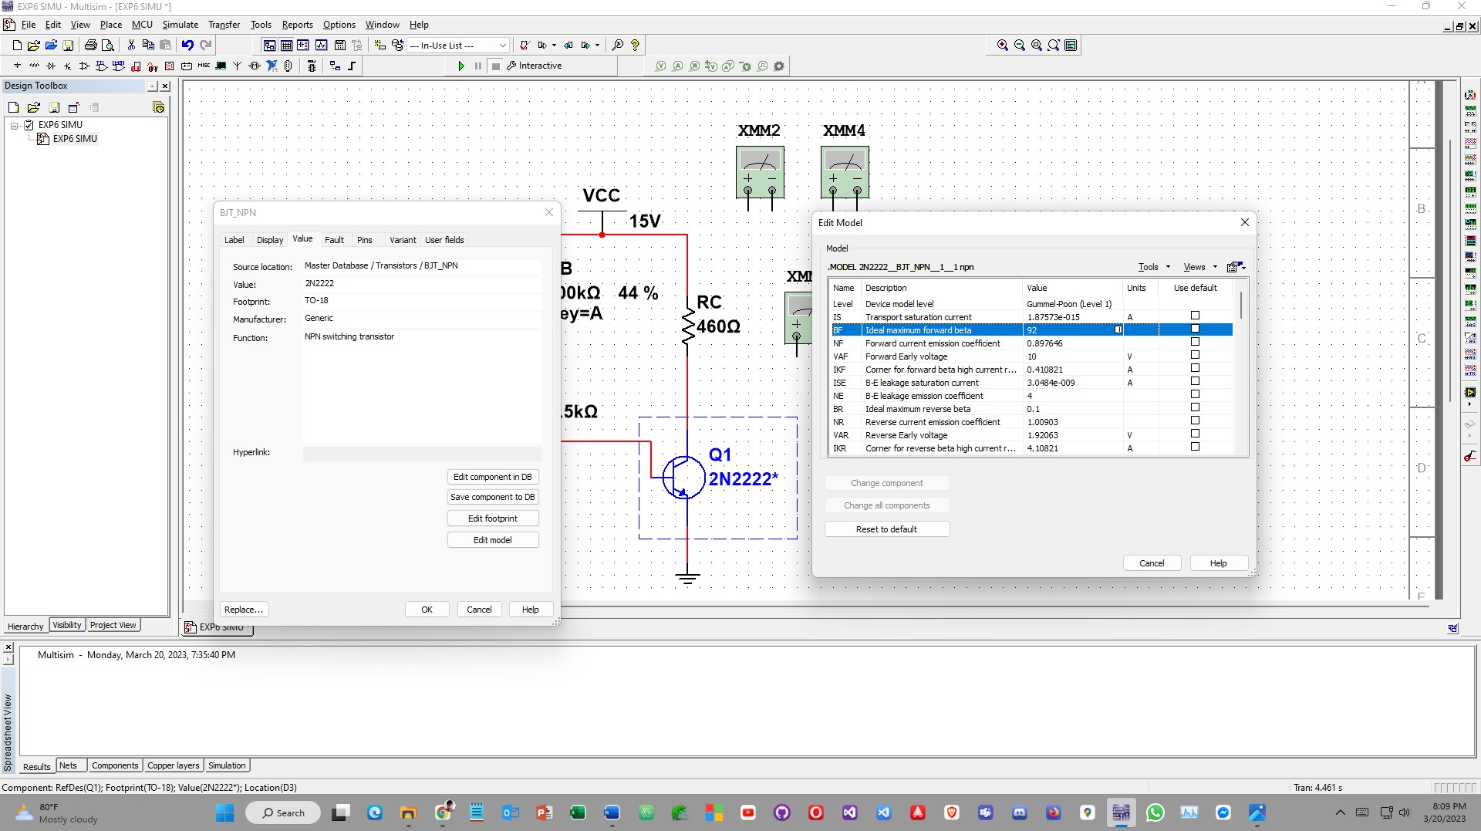

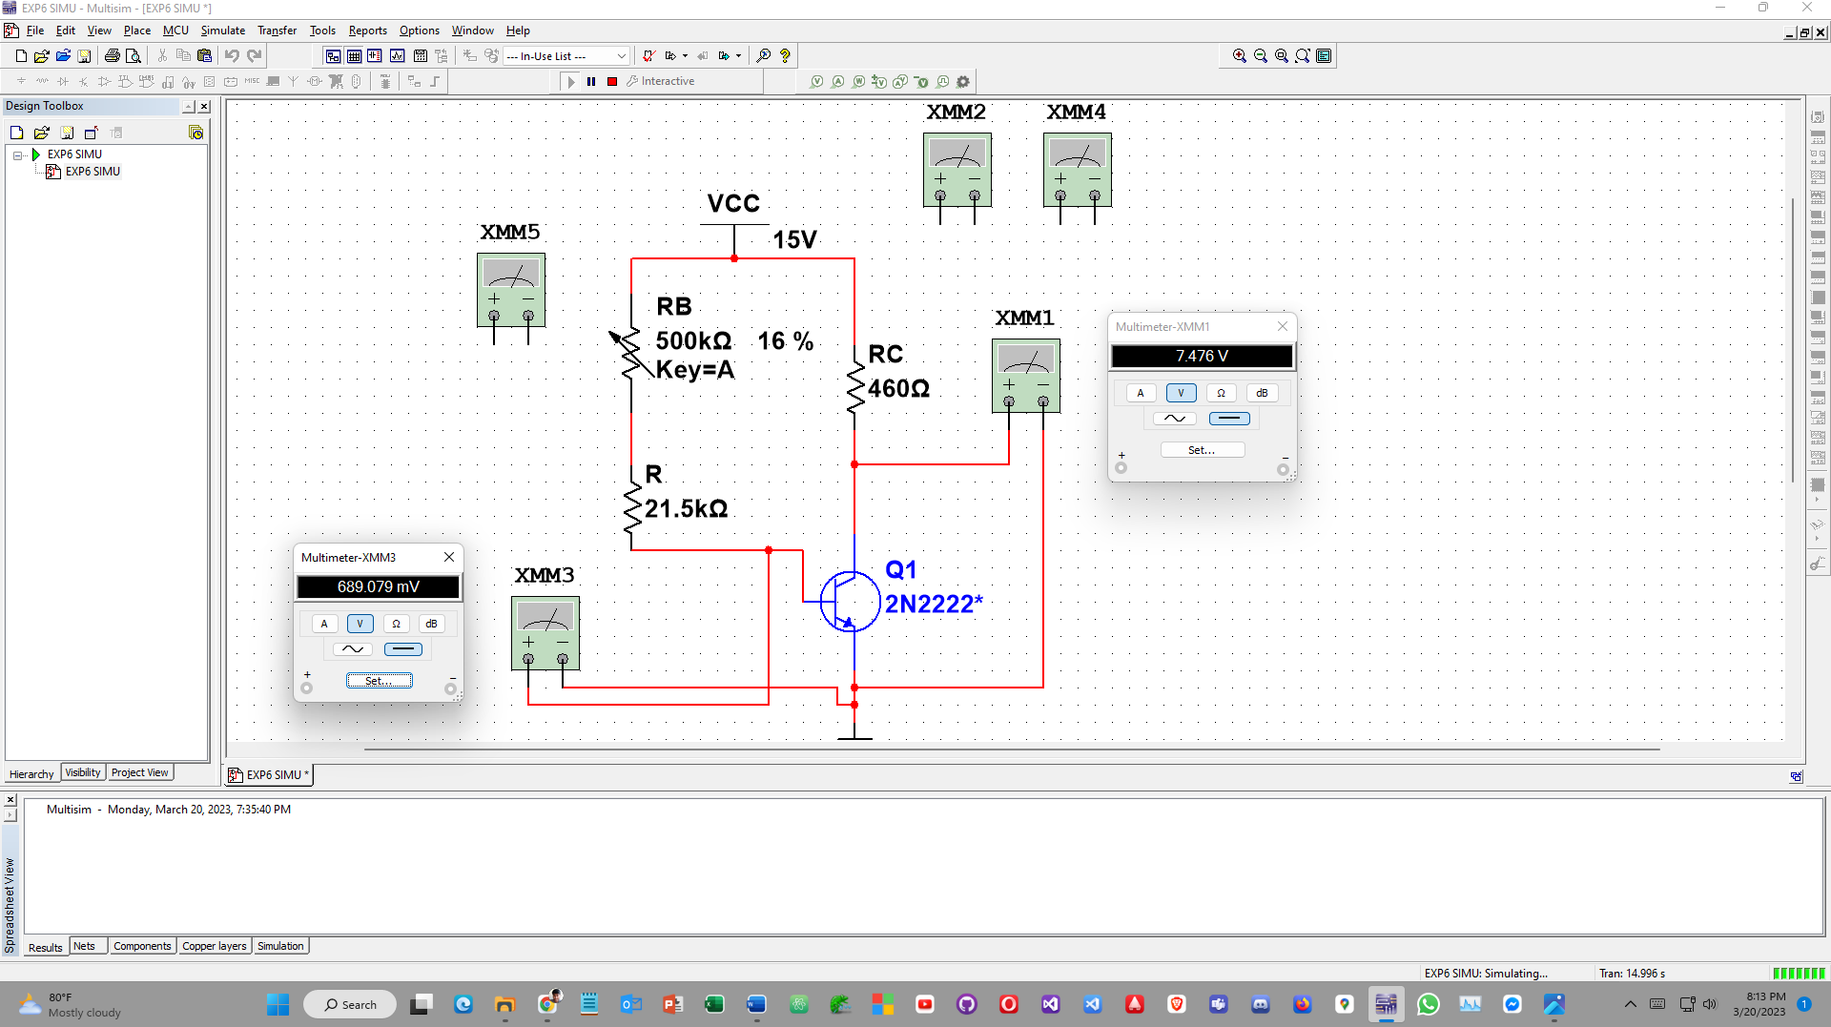

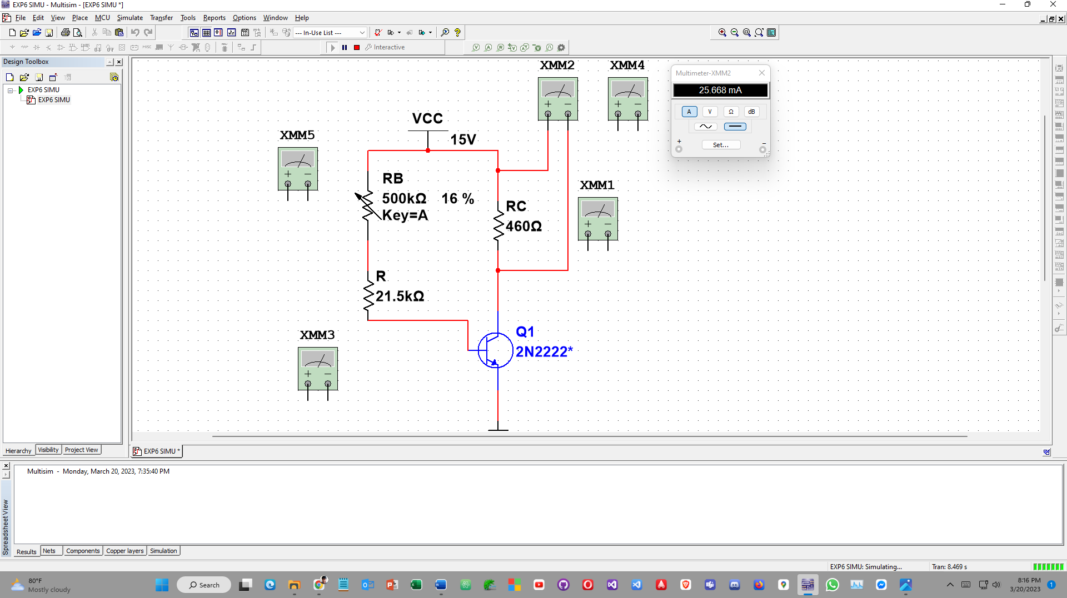

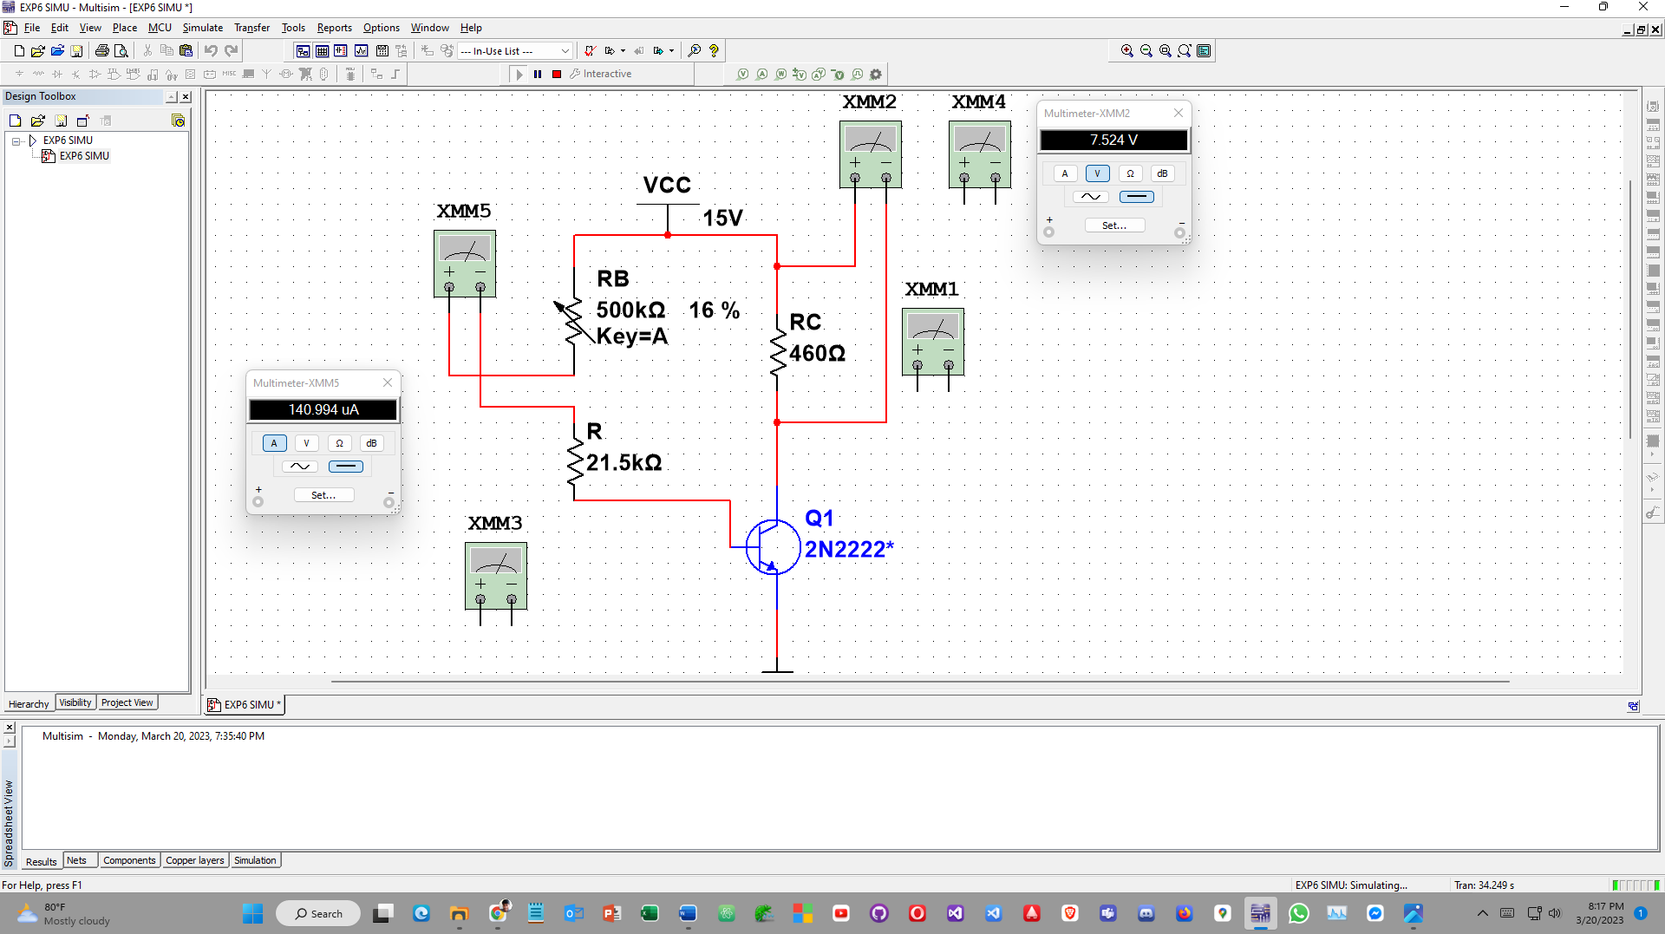

# Fixed bias(beta = 210)

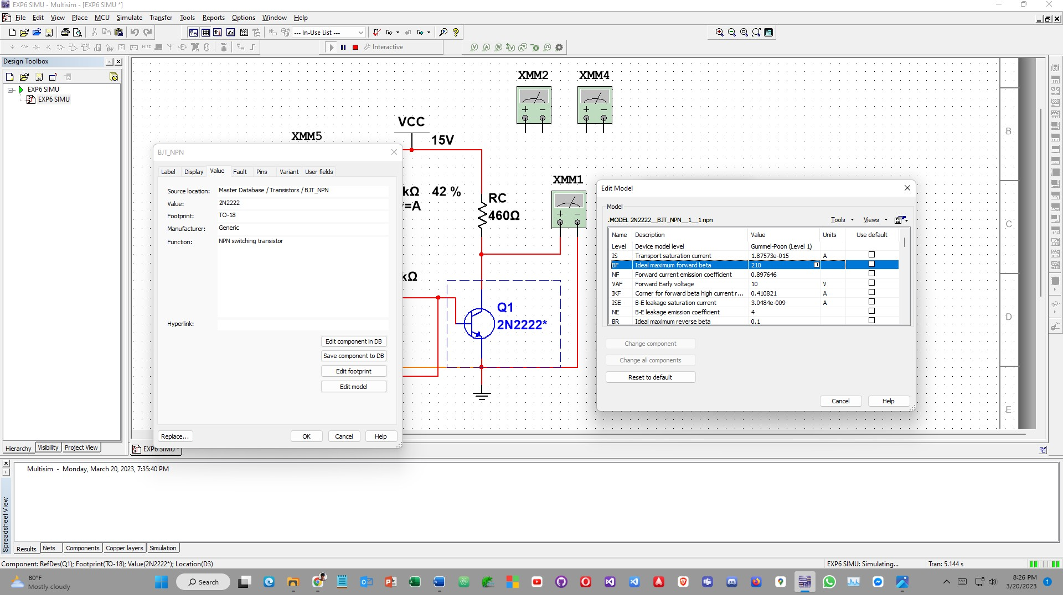

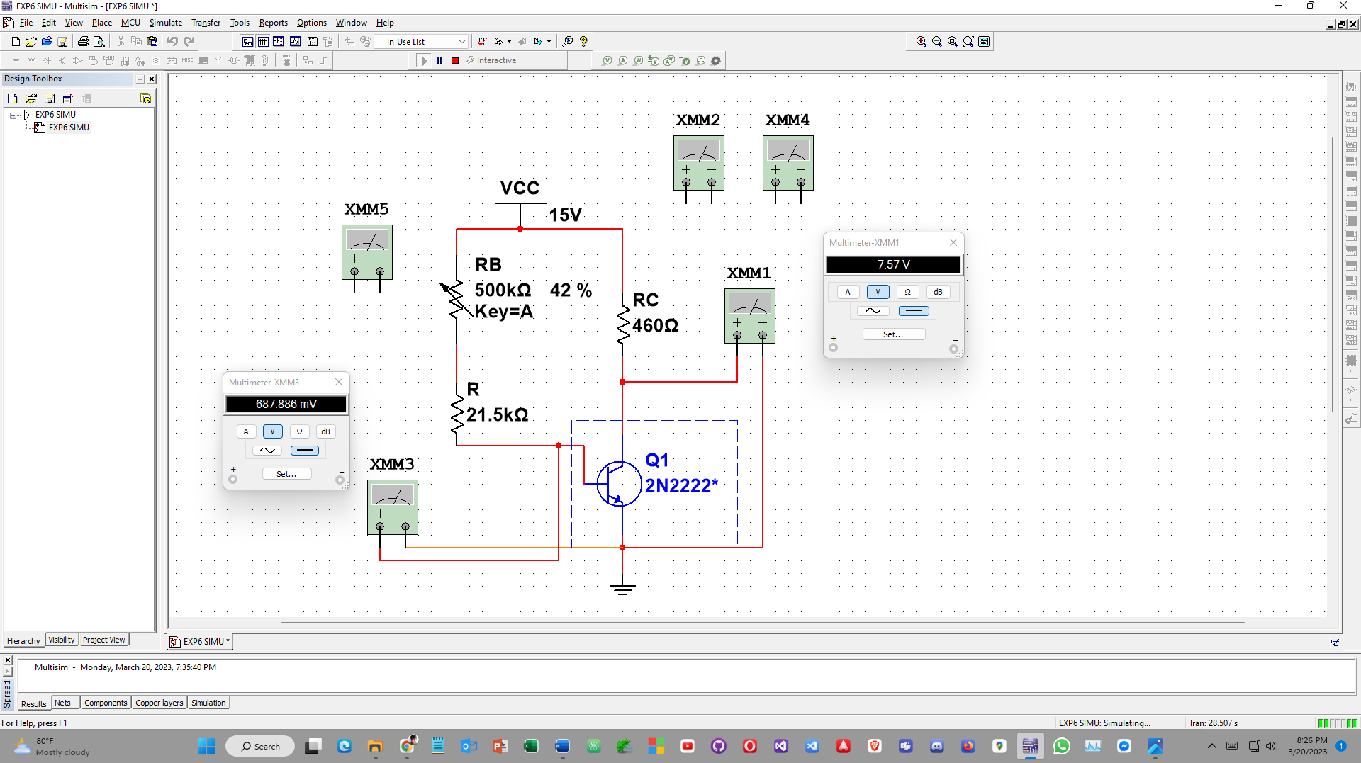

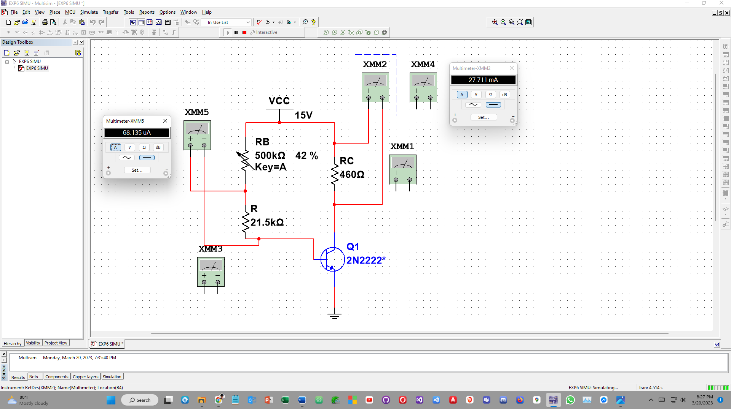

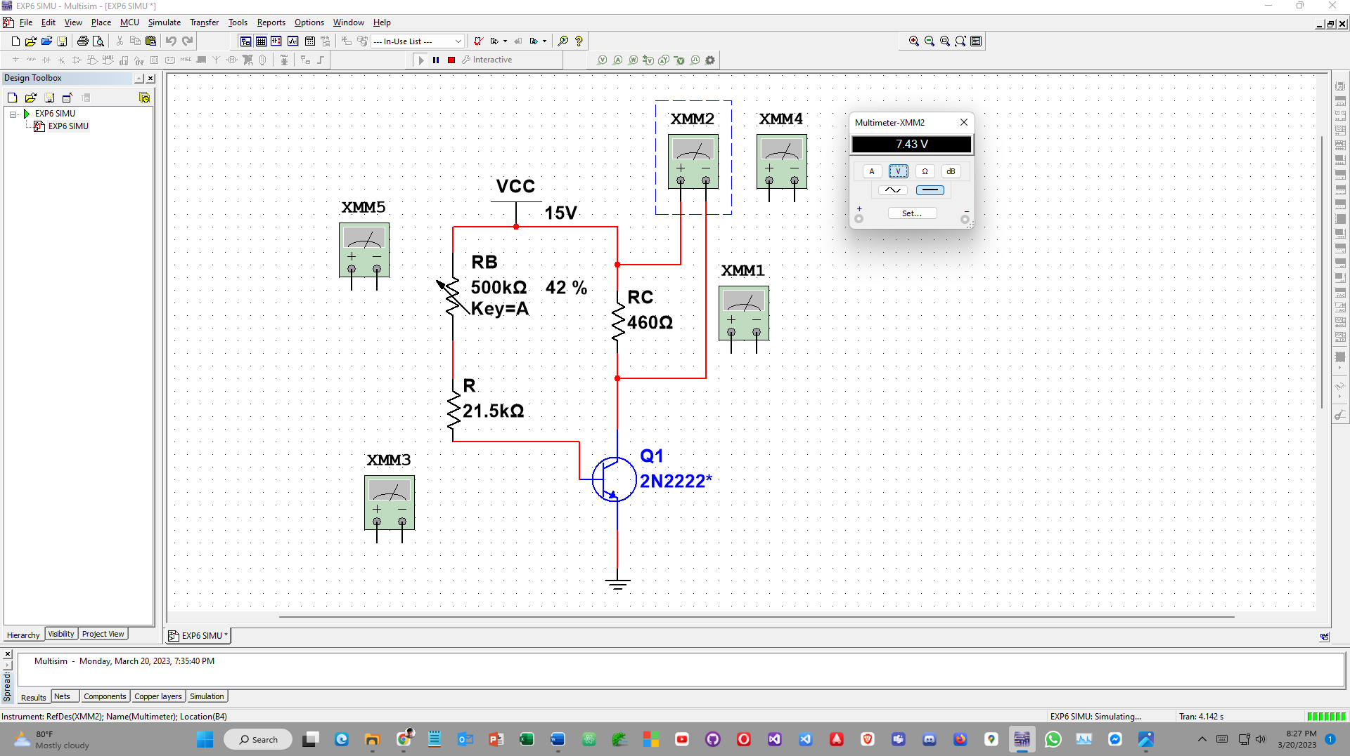

**Emitter bias(beta = 92)**

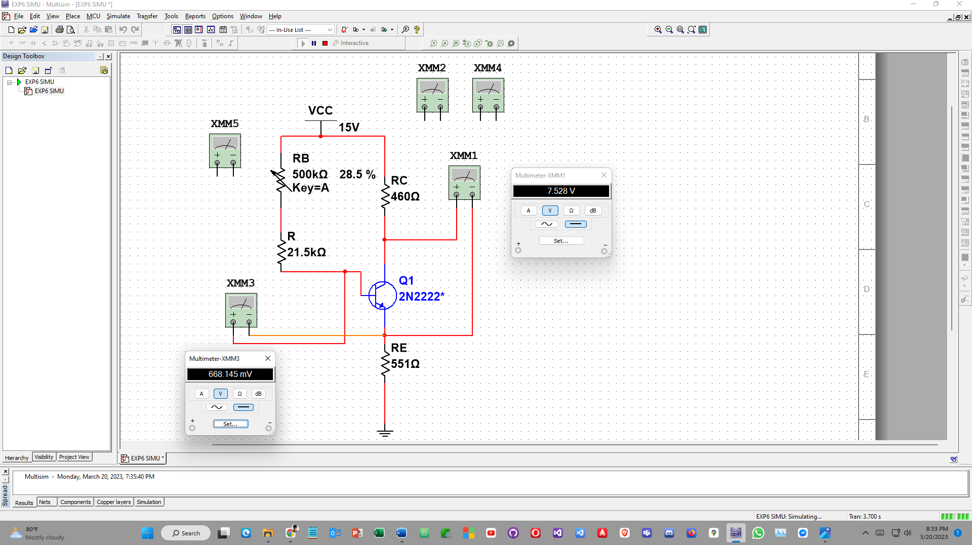

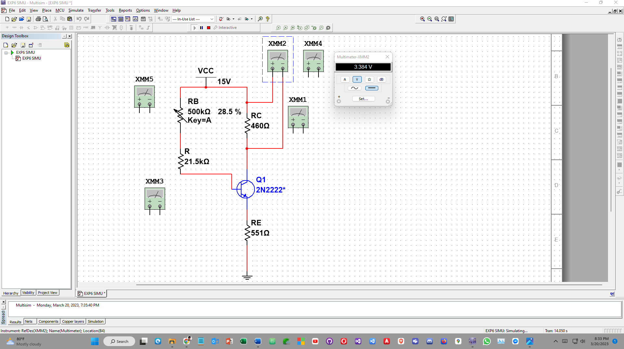

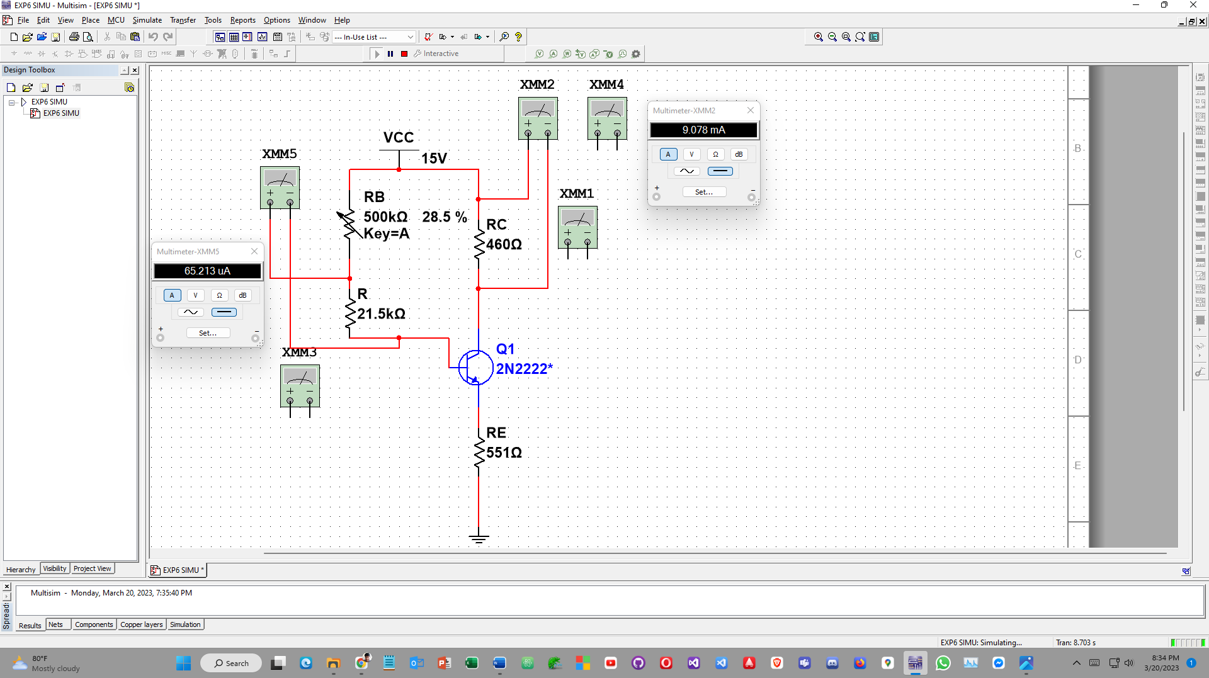

# Emitter bias(beta = 210)

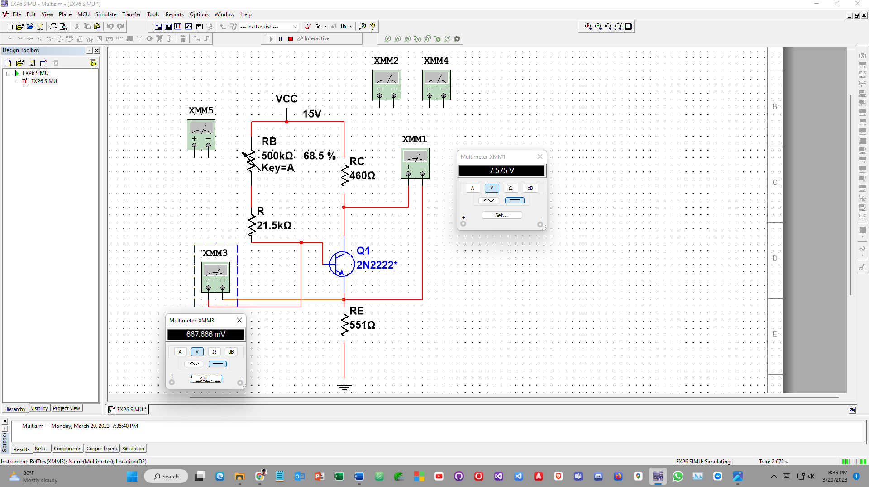

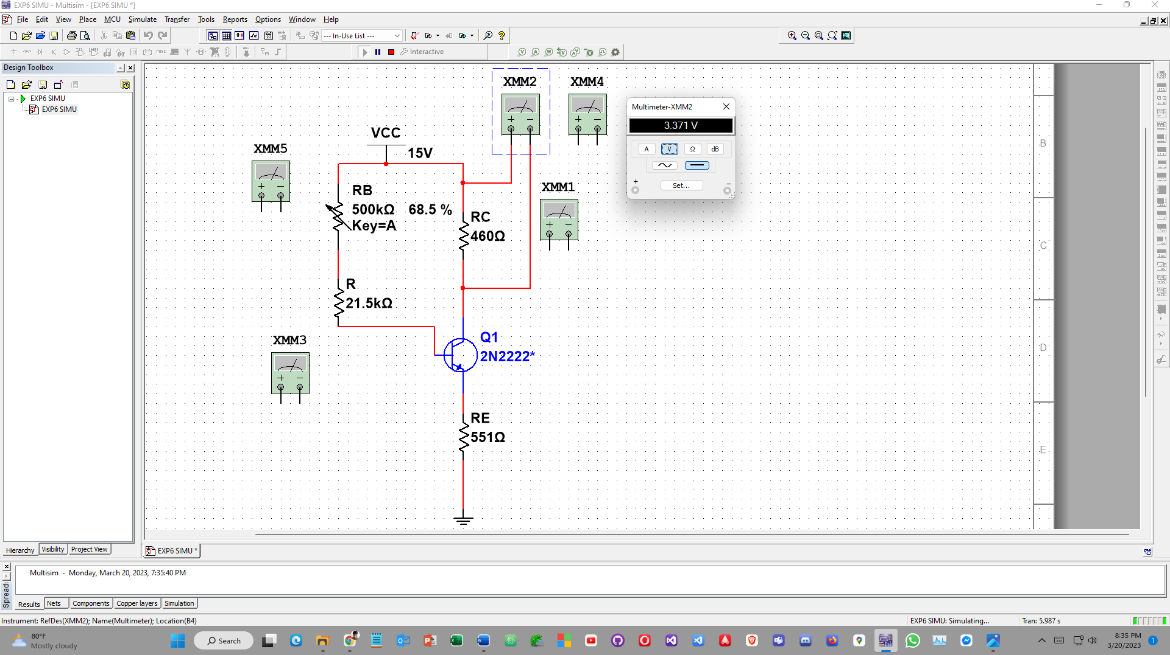

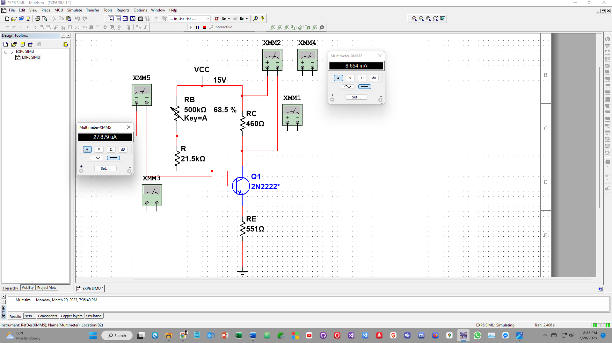

**Voltage divider bias (beta = 92)**

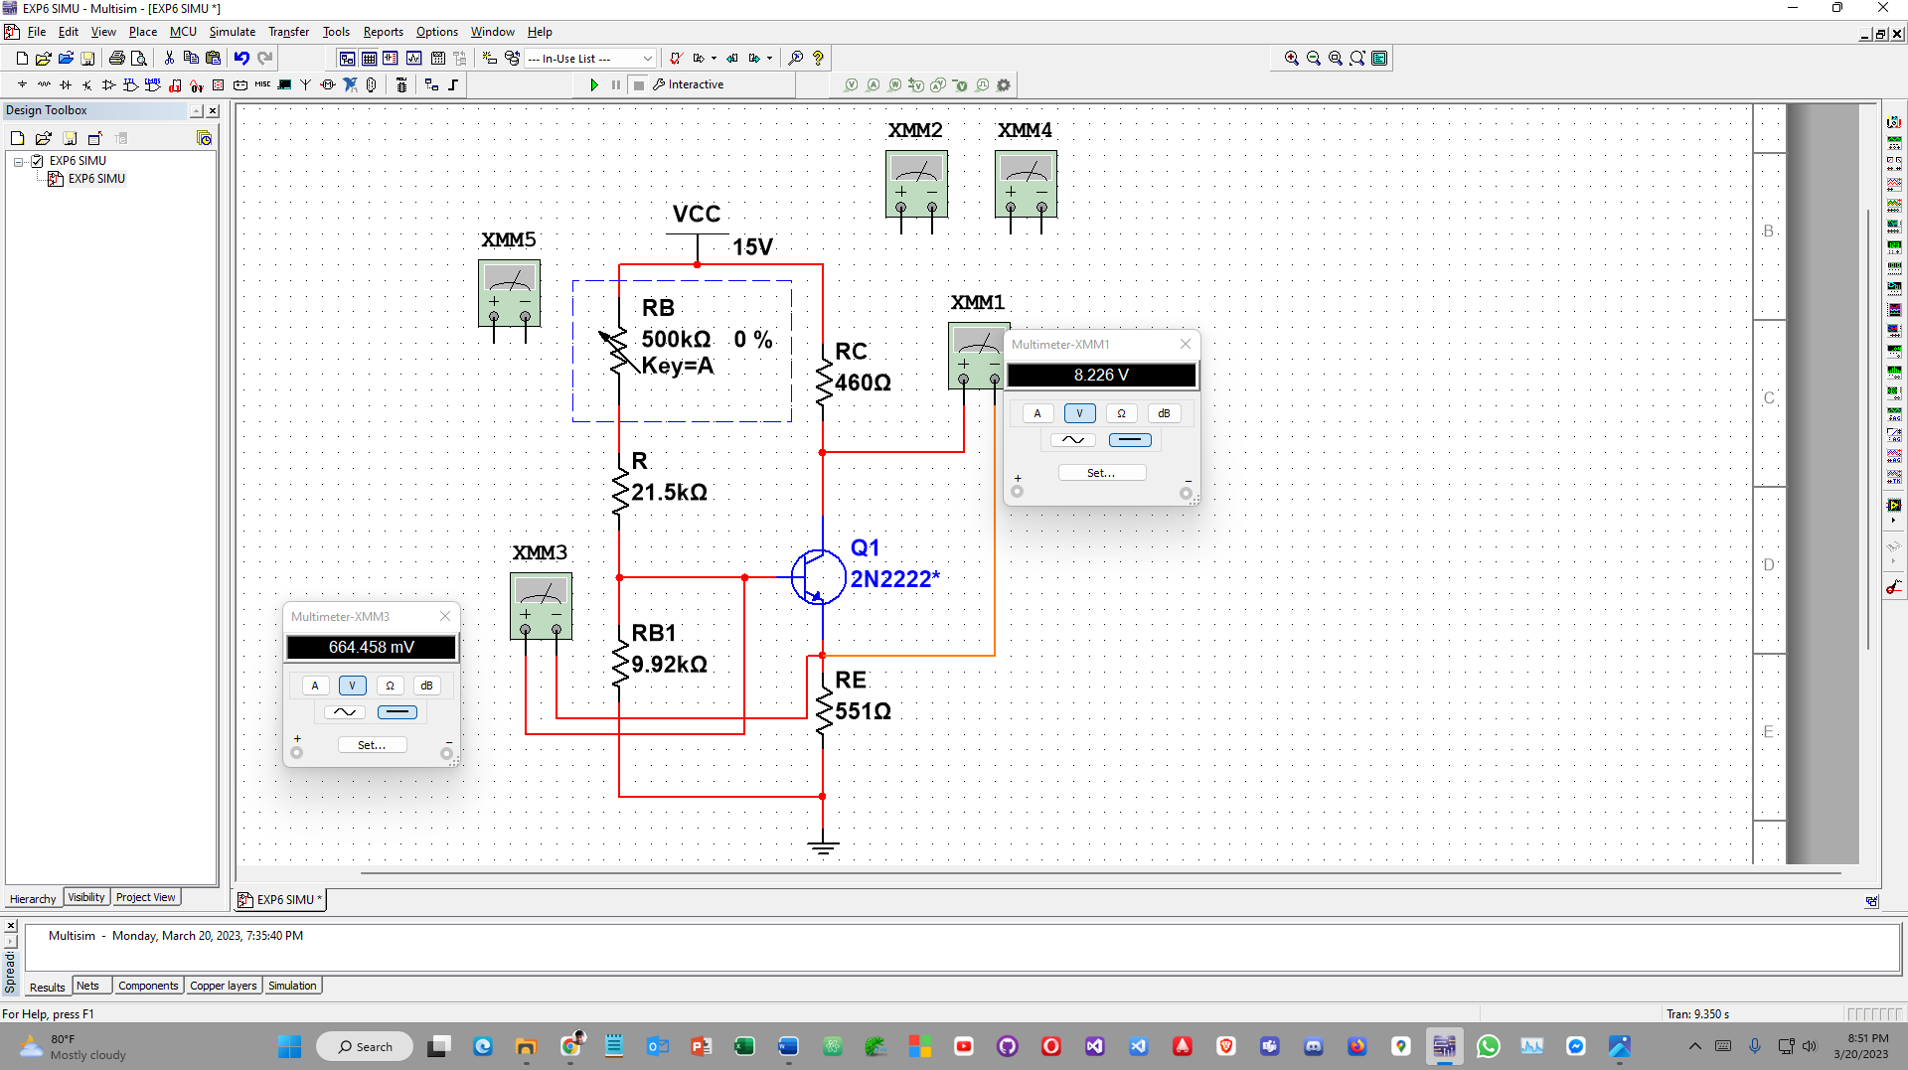

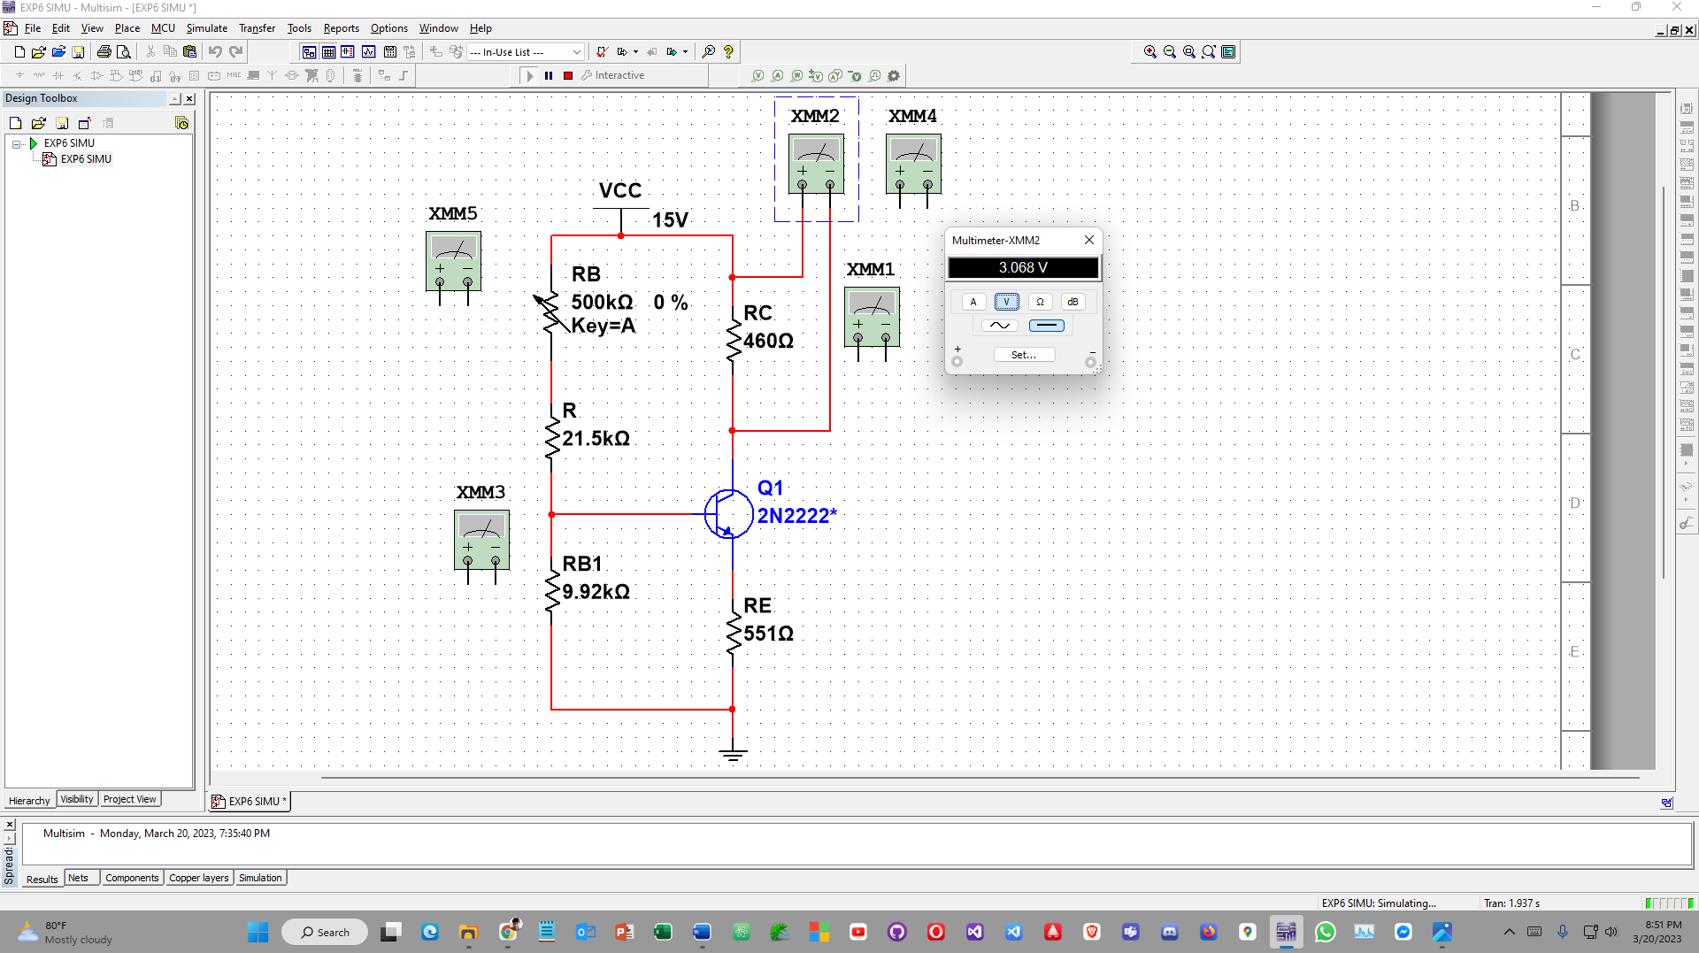



# Voltage divider bias(beta = 210)

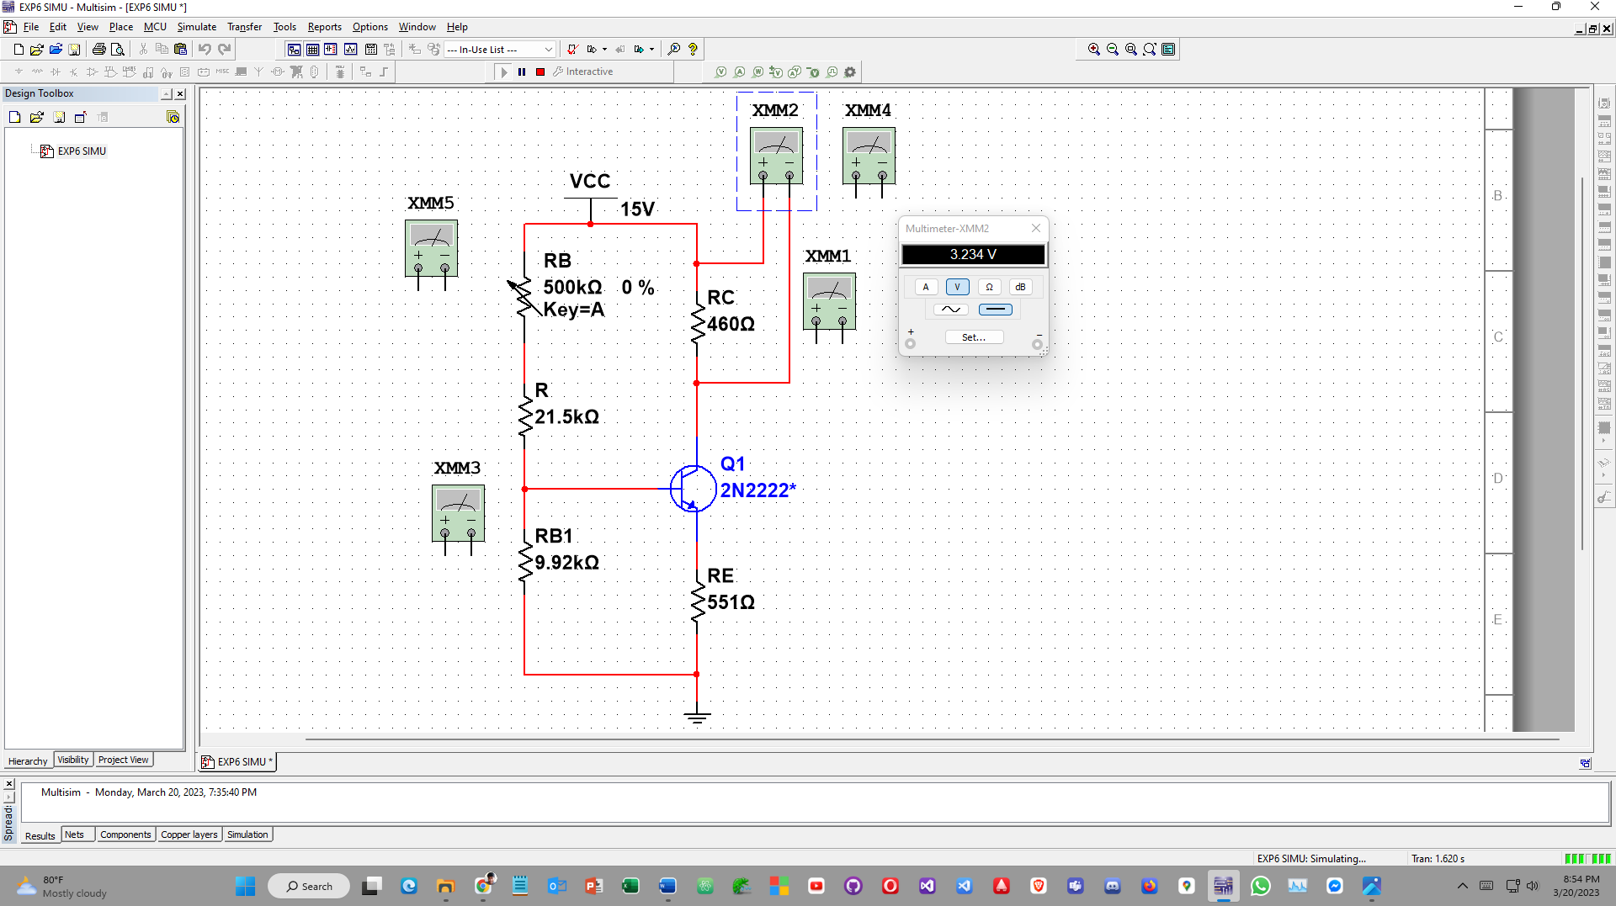

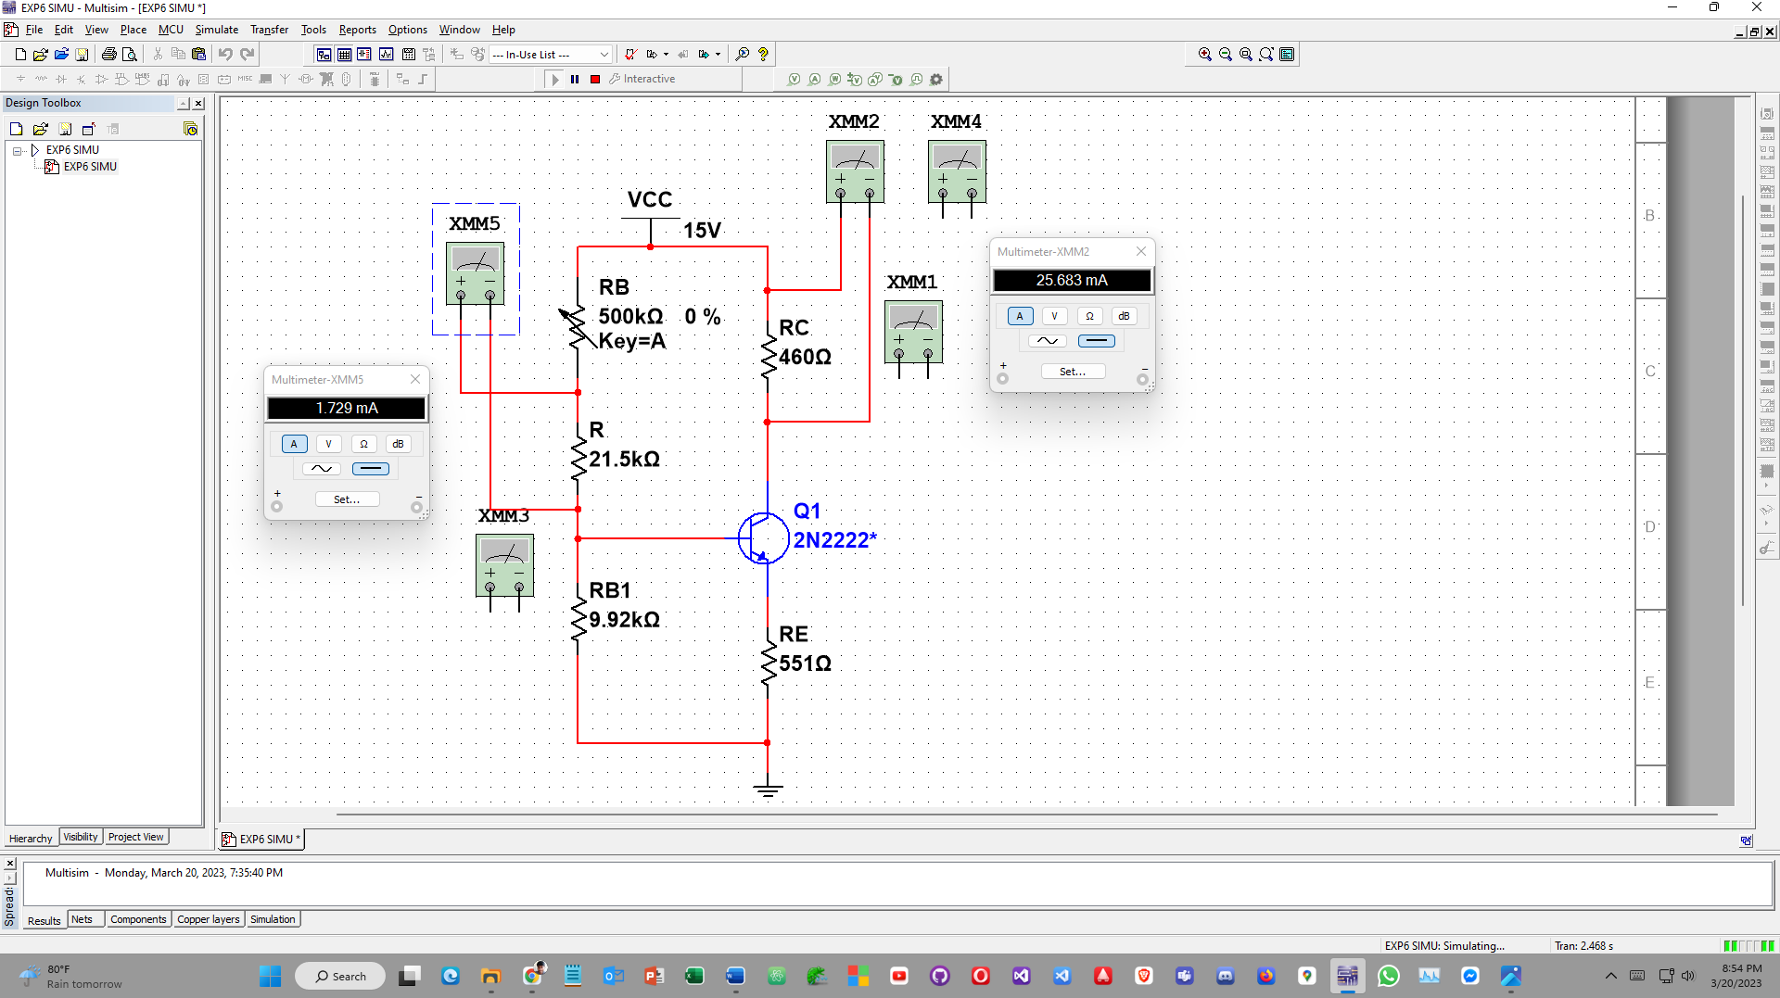

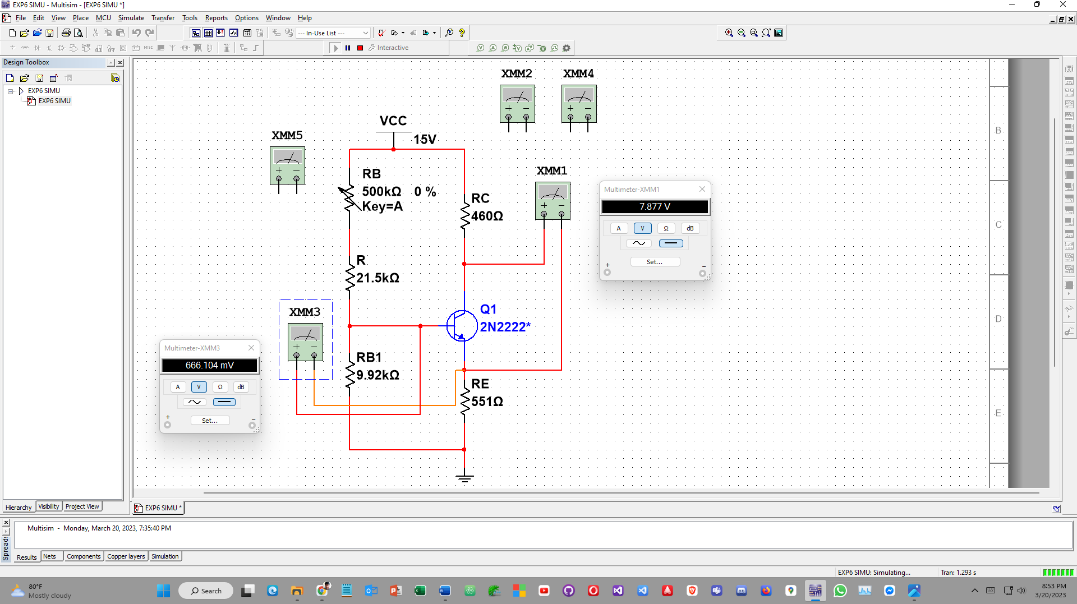

**K.Discussion:**

1. Biasing means to apply a fixed DC voltage to an electronic component like a transistor in order to establish proper operating conditions for the component. By biasing a transistor, it can be made to operate at certain conditions in the active region. Due to biasing a signal can be amplified using a transistor in an undistorted state.
2. It is to be noted that when, Ic = Ic(max)/2 & Vce = Vcc/2 then the amplification is maximum.
3. The addition of RE in the circuit in figure 2 (b) caused greater stability in the transistor. As a result the variation in β was reduced from 1.35% down to 0.000734%, indicating that the amplified signal has less noise in it.
4. In case of fixed-bias circuit, figure 2 (a), the stability depends upon the transistor and we cannot control the stability easily. As a result, the operating point may shift unwillingly. But in case of self-biase configuration or voltage divider configuration, we can control the stability by changing the emitter resistor, RE, in the circuit. Thus, self-biased configuration gives us more stability than fixed-biased configuration.
5. For a transistor to act as an amplifier this gain has to be constant. This consistency in its gain is called its stability and can be characterized by the change in amplification or gain (β) during operation. The operating point or Q point is the constant dc voltage or current given to the collector terminal for its operation. When transistor acts as an amplifier, this point has to be maintained constant, that is where biasing helps, by providing this constant dc collector voltage.

**L. Reference(s):**

[1] American International University–Bangladesh (AIUB) Electronic Devices Lab Manual.

[2] A.S. Sedra, K.C. Smith, Microelectronic Circuits, Oxford University Press (1998)

[3] J. Keown, ORCAD PSpice and Circuit Analysis, Prentice Hall Press (2001)

[4] P. Horowitz, W. Hill, The Art of Electronics, Cambridge University Press (1989).